Healthcare Claims & Fraud Analysis
Summary: Create secure database system for storing, viewing and analyzing patient health records and implement automated rules and dashboards to detect and prevent suspicious insurance claims and potential fraud.
Database Architecture:
- Patients Table
Purpose: Store personal data about each patient and identify their medical provider.
Key Columns: Patient_ID (Primary Key), Patient_Name, Age, Gender, Phone_Number, Address, Provider_ID (Foreign Key), SSN, Email
- Provider Table
Purpose: Identify medical providers and their insurance information.
Key Columns: Provider_ID (Primary Key), Claim_ID (Foreign Key), Provider_Name, Specialty, Provider_Address, Insurance_Number, Hospital_NAME
3. Claims Table
Purpose: Store and manage claims submitted by healthcare providers, linking each claim to its corresponding patient and provider. Provides the main source of information for analyzing suspicious claims.
Key Columns: Claim_ID(Primary Key), Patient_ID (Foreign Key), Provider_ID (Foreign Key), Date_Service, Procedure_Name, Amount_Claimed, Status
4. Fraud Table
Purpose: Store claims and rules for determining anomalous claims. Each score is assigned a risk score according to how it meets the criteria. A claim is marked as suspicious if it meets one or more of the following criteria:
-The claim amount is greater than $2,000
-The same procedure was charged more than once on the same day
-The provider and patient were not located in the same state
- The service was performed by the provider on a Saturday or Sunday
-The claim was for a procedure with an unusual name
Key Columns: Claim_ID (Primary Key), Provider_ID (Foreign Key), Patient_ID (Foreign Key), Risk_Score, Expensive_Claim, Rare_Procedure, Duplicate_Claim, Suspicious_Provider, Weekend_Service, Reason
5. Audit_Claims
Purpose: Maintains an audit trails of claim inserts, modifications or deletions generated by triggers to support data monitoring and integrity.
Key Columns: Record_ID (Primary Key), Action, Action_Time, User, Audit_ID, Old_Provider_ID, New_Provider_ID, Old_Procedure_Name, New_Procedure_Name, Old_Amount_Claimed, New_Amount_Claimed, Old_Status, New_Status
Methods and Procedures Used
SQL Methods
JOIN – Combined data from Patients, Providers, and Claims tables to analyze claims
Aggregate Functions – Calculated the maximum/minimum of columns and the most/least frequently occurring values using the COUNT and SUM functions using ORDER BY, SORT, GROUP BY and HAVING clauses.
Wildcard Statement Matching – Detected suspicious sounding procedure names using LIKE operator and wildcard characters.
Conditional Logic – Assigned values to rows in column based on logic in CASE statement and used IF in queries to obtain results.
Triggers and Audit Logging
Created triggers to capture changes in the claims table to detect unauthorized modifications.
Update_claim: Records when existing claims are modified.
Insert_claim: Records when new claims are added to the claims table.
Delete_claim: Records when claims are deleted from the claims table.
Views
Created a view that protects patients’ sensitive personal information from being accessed by unauthorized individuals.
Masks – view that masks patients’ Social Security Number, email address and phone number by returning an “x” instead of the actual value.
Procedures
Saved queries that are repeated often as procedures to help automate claim analysis.
SUMMARY_Claims() – procedure that summarizes claim information by provider.
Unusual_Age() – procedure helps detect potentially fraudulent claims by returning patients who are extremely old.
Provider_Least_Claims() – procedure identifies the current provider who has filed the least number of claims.
Expensive_Pending() – procedure that helps administrators investigate potentially fraudulent claims by returning claims over $2,000 that are pending.
Visualization and Monitoring
Configured MySQL healthcare database as a data source in Grafana to create dashboards and tables that visualize key statistics and anomalous claims.
Grafana Dashboards and Panels
Fraudulent Claims by Provider – shows the number of potentially fraudulent claims by each provider broken down by type
Claims over the past 5 years – plots the number of claims per year
Count of Patients and Claims by Provider – summary of patients, claims submitted and amounts charged for each provider
Claim Status Panel – highlights the total number of pending, denied and paid claims
Claim Amount Distribution – visualizes distribution of the claim charges
Percent of Suspicious Claims by Type – visualizes distribution of fraudulent claims by type
Results
-Provider with highest number claims flagged as suspicious: David Brooks
  - 23 claims flagged suspicious, the highest contributor being weekend services.
-Audit log showed 3 expensive procedures’ (>$2,000) status were changed from “Pending” to “Paid”
Risk Indicator | Percentage of Claims | Notes
Pending for further review | 14% | Claim status was pending
Weekend Procedure | 34% | Procedure took place on a Saturday or Sunday
Duplicate Claims | 13% | More than 1 claim was filed for the same procedure on same day
Expensive Claims | 22% | Claims charging over $2,000
Nonstandard Procedures | 13% | Procedures with odd or frivolous sounding names

Conclusions
The project implemented a secure healthcare system database to store patient, provider, and claim data. An audit framework was developed to detect when new claims are entered, or existing claims are altered or deleted so full visibility can be maintained on records in compliance with healthcare data regulations. Rules were implemented to detect potentially fraudulent claims for further investigation. Dashboards were created in Grafana to visualize key metrics and anomalous claims.

Appendix
ER Diagram
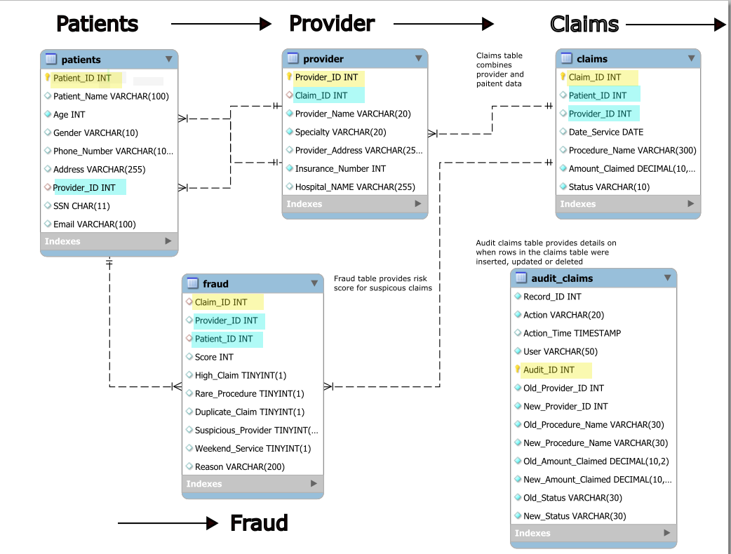

Fraudulent Claims by Provider Bar Chart
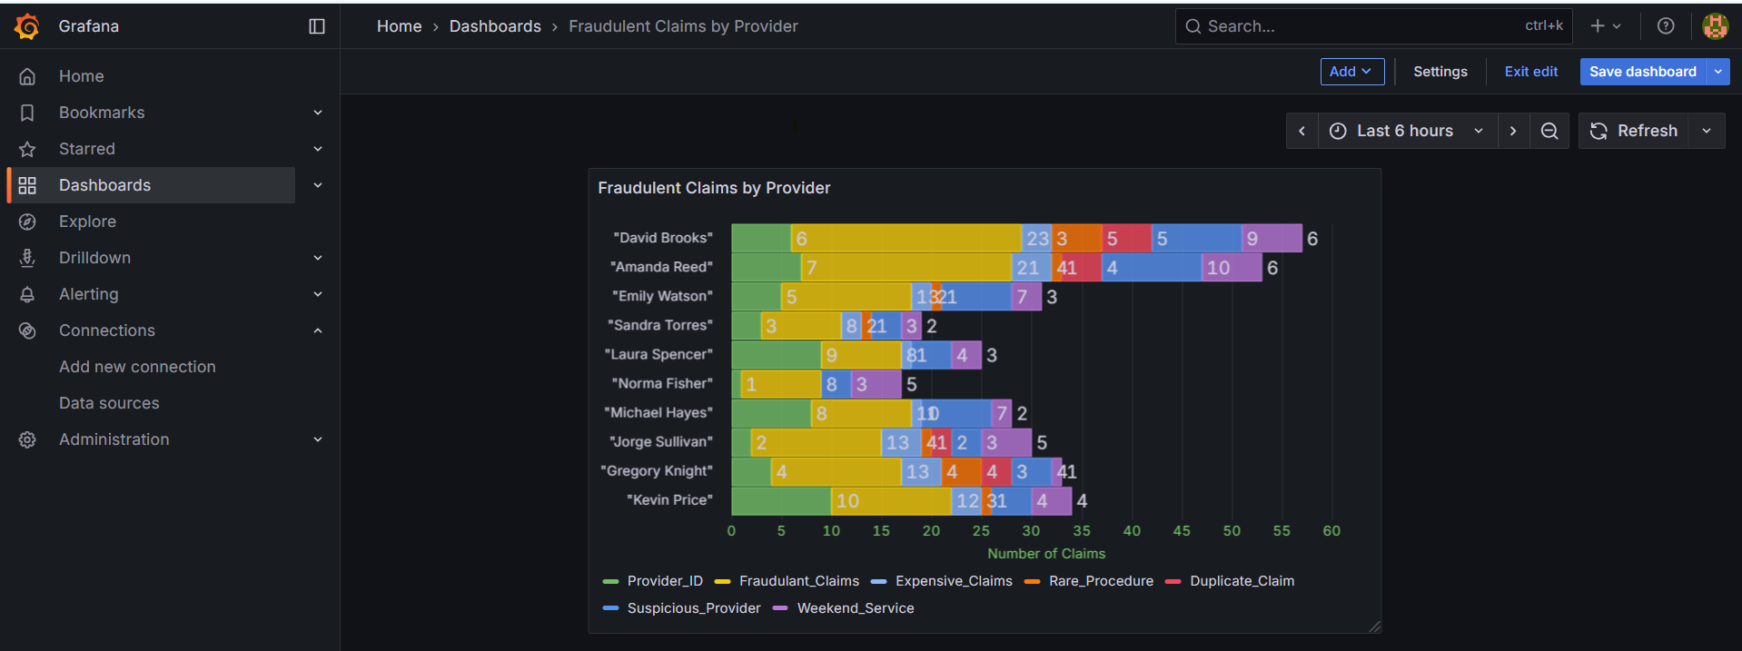
Claims Over Past 5 Years Line Chart
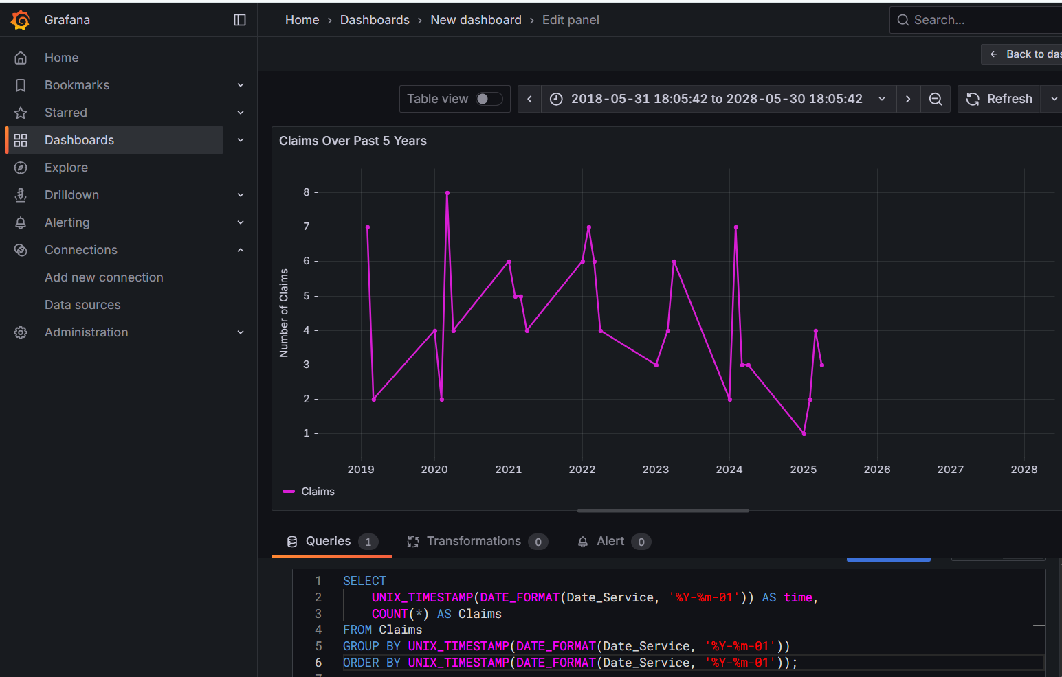

Count of Patients, Claims by Provider
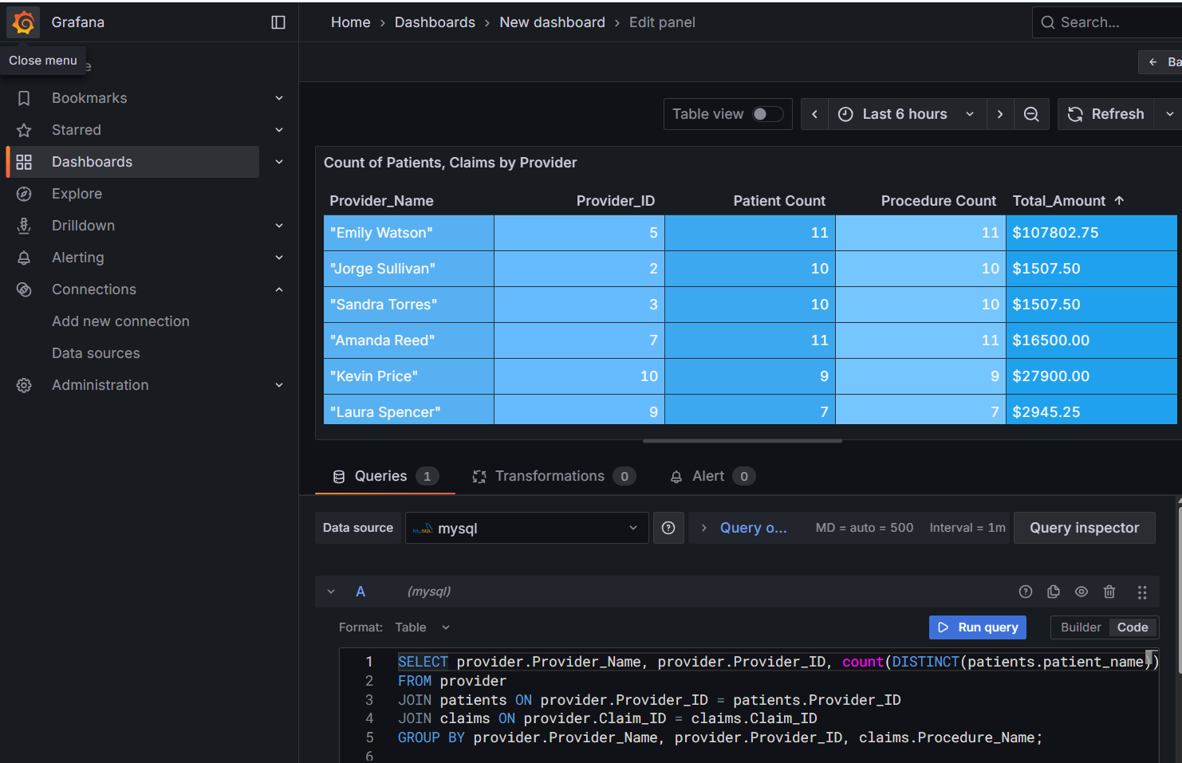
Pending Status Panel
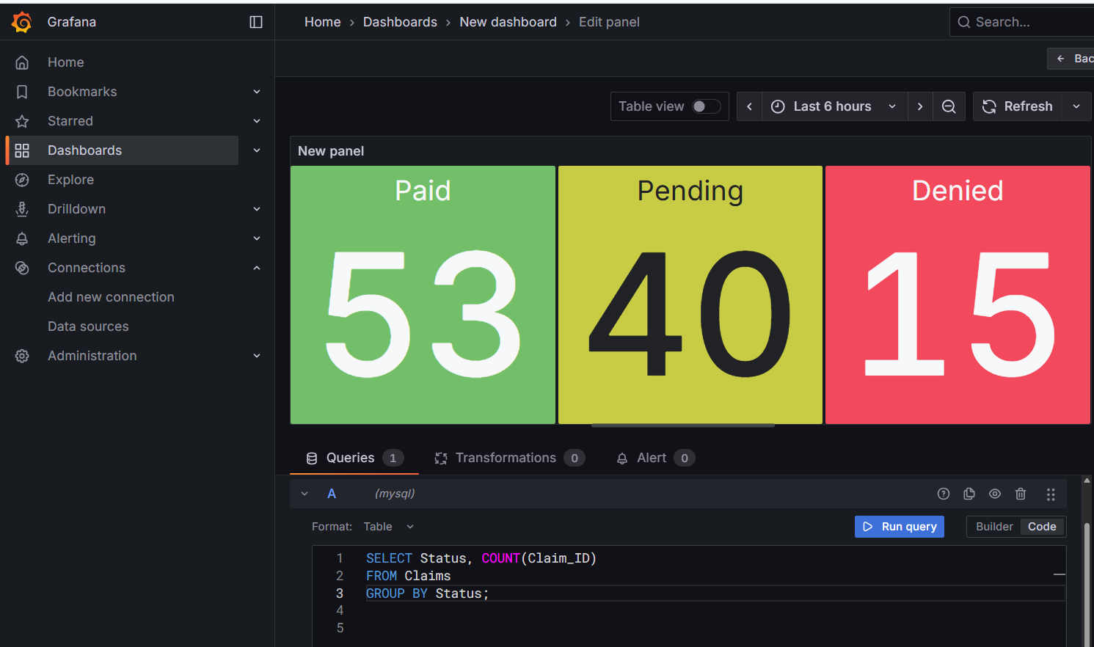
Claim Amount Distribution Bar Chart
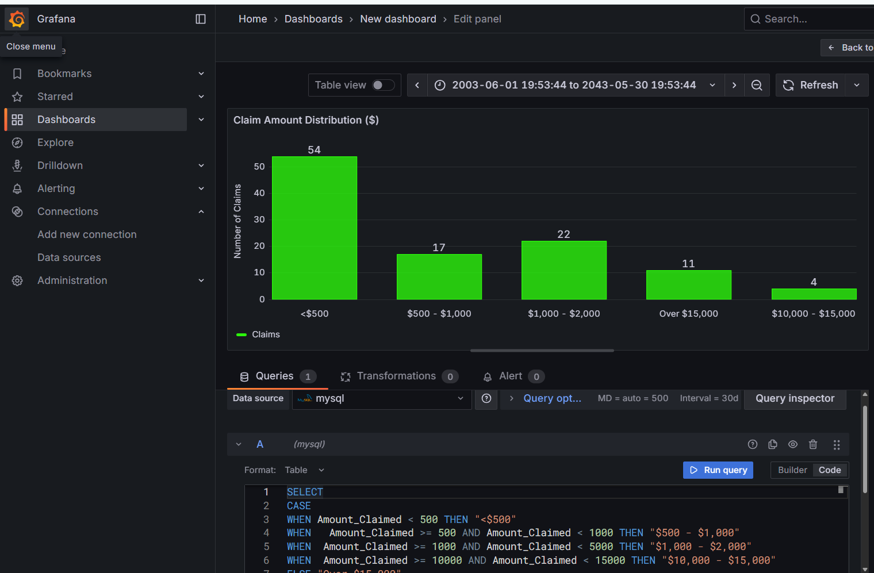
Percent of Suspicious Claims by Type Chart
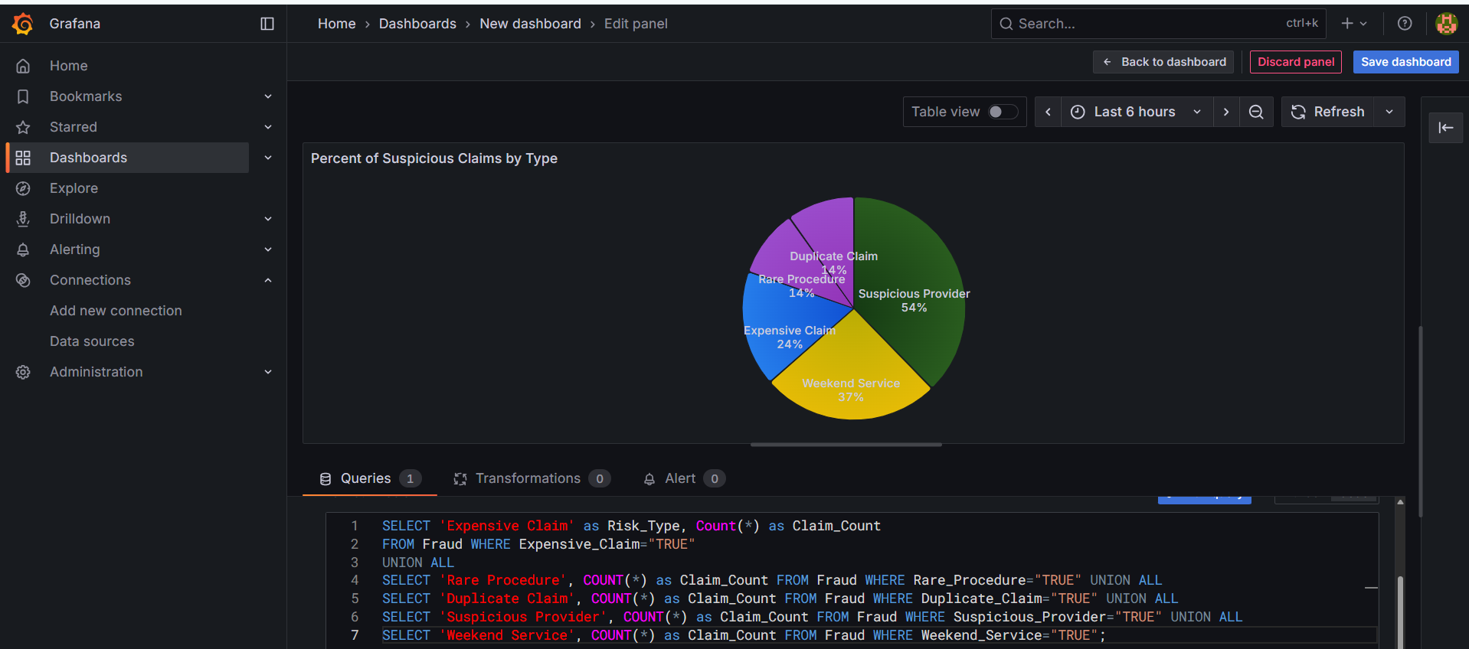

SUMMARY_Claims() PROCEDURE Output
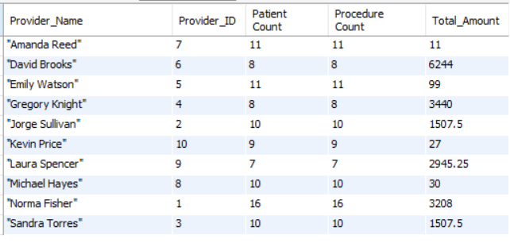
Provider_Least_Claims() PROCEDURE Output
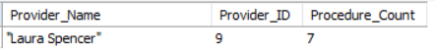
Unusual_Age() PROCEDURE Output
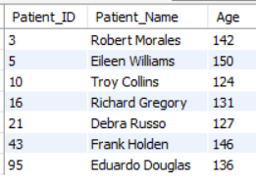
SUSPICOUS_PROCEDURES VIEW Output
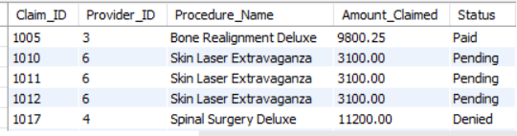

Expensive_Pending() PROCEDURE Output
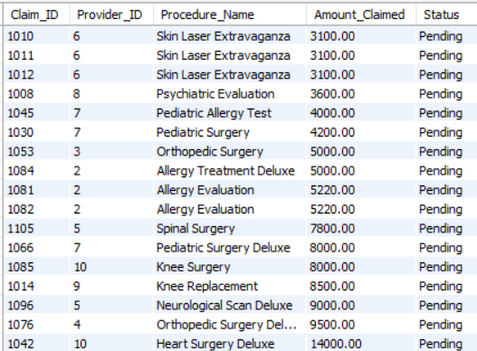
Unusual_Age() Procedure Output
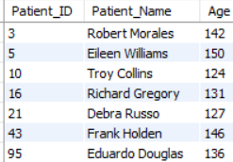
Summary_Claims() Procedure Output
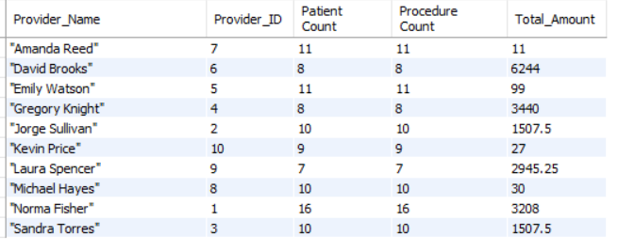

Fraud Table
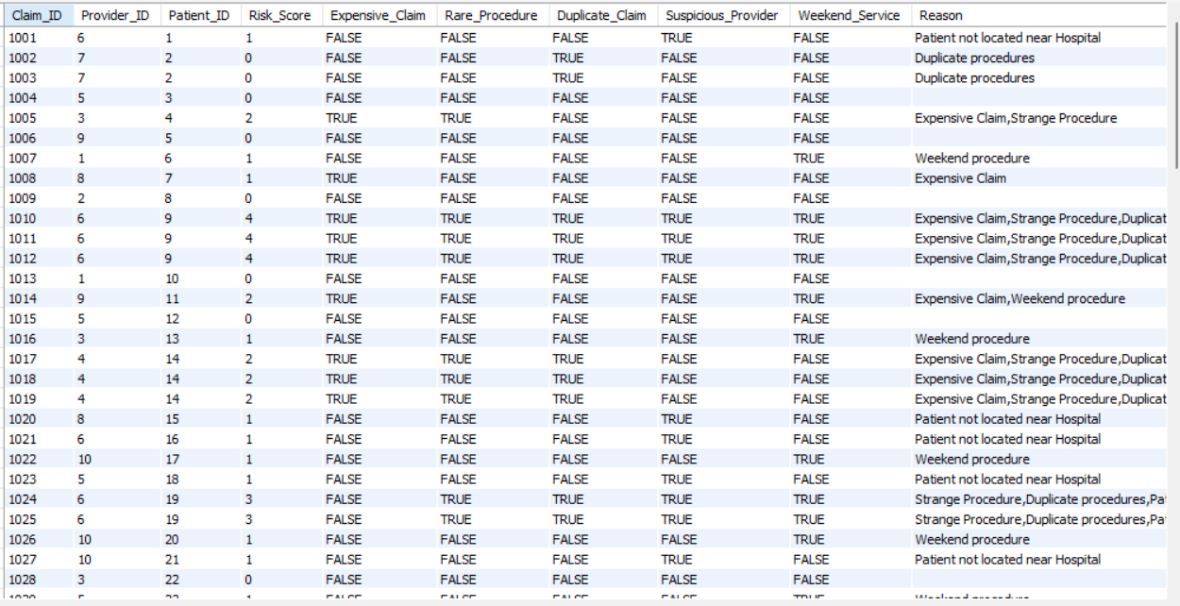
Claims Table
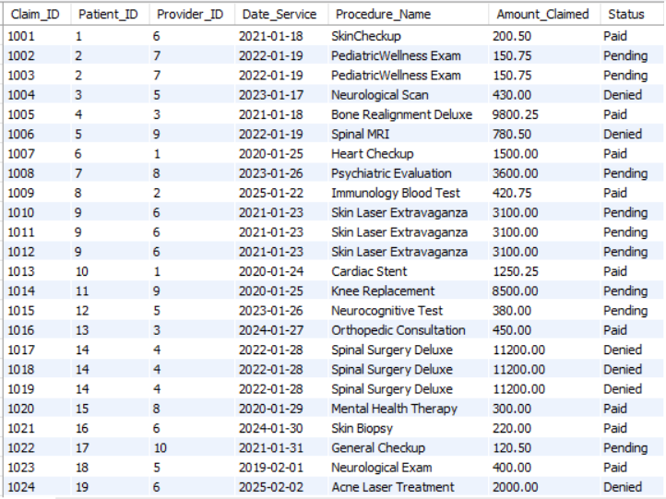

Patients Table
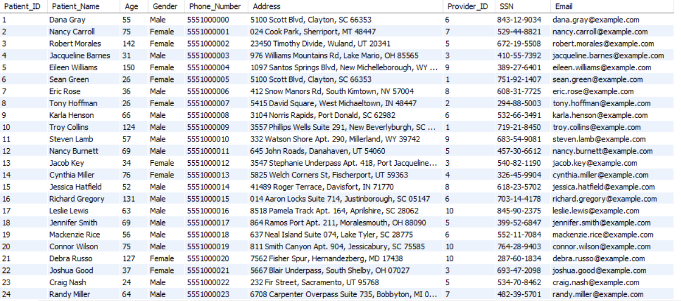
Provider Table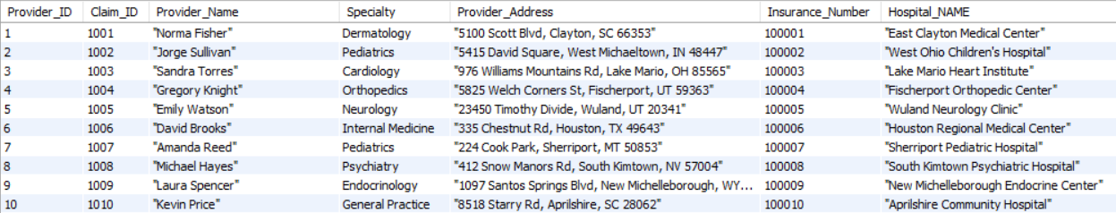
Audit_Claims Table
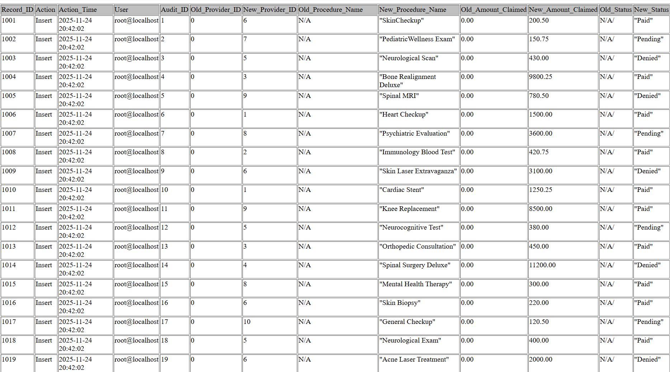
Masks VIEW Output
